CREATE TABLE students (
Studentid INTEGER NOT NULL PRIMARY KEY,
Firstname VARCHAR(50) NOT NULL,
LastName VARCHAR(50) NOT NULL,
Class INTEGER,
Age INTEGER
);

CREATE TABLE marksheet (
StudentID INTEGER NOT NULL PRIMARY KEY,
Score INTEGER NOT NULL,
Year INTEGER NOT NULL,
Class INTEGER NOT NULL,
Ranking INTEGER NOT NULL
);

INSERT INTO students (Studentid, Firstname, LastName, Class, Age)
VALUES (1, 'krishna', 'gee', 10, 18);

INSERT INTO marksheet (StudentID, Score, Year, Class, Ranking)
VALUES (1, 989, 2014, 10, 1);

--Student whose age is greather than 16 and last name 'kumar'
SELECT StudentID,firstName,LastName
FROM students
WHERE Age >16
AND LastName = "kumar";

--Every student from Marksheet whose score is between 800 and 1000
SELECT *
FROM Marksheet
WHERE SCORE BETWEEN 800 AND 1000

--Increase the score in the marksheet table by five
--and create a new score column to display this new score
ALTER TABLE marksheet
ADD COLUMN NewScore INTEGER;

UPDATE marksheet
SET NewScore = Score + 5;

--Display the marksheet table in descending order of the score
SELECT *
FROM marksheet
ORDER BY score DESC;

--Display the details of every student whose first name starts with ‘a’
SELECT *
FROM students
WHERE Firstname LIKE 'a%';

DIAGRAMA ERD
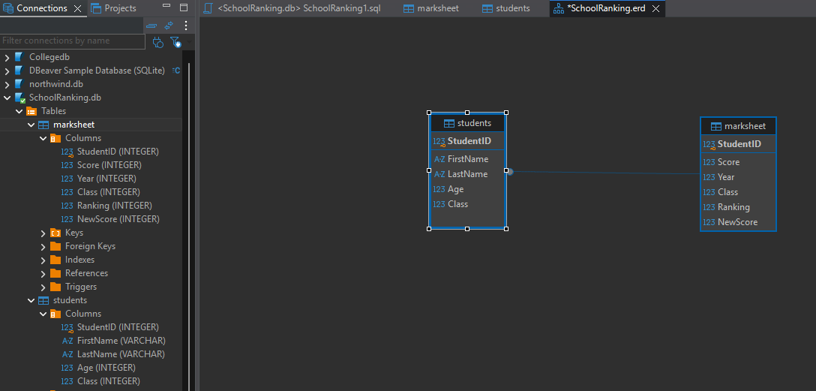
STUDENT DATA
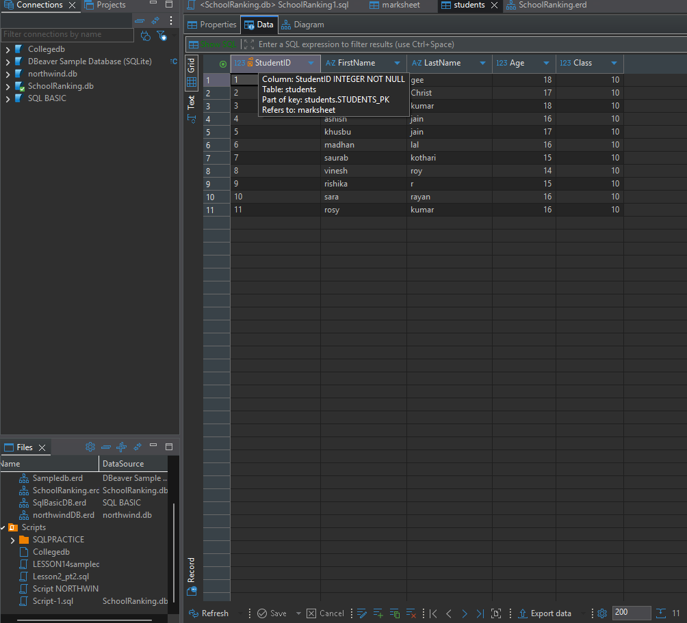

MARKSHEET DATA
